北京邮电大学软件学院
2019-2020学年第二学期实验报告

课程名称： 多媒体技术与应用

项目名称： 实验1——图像文件处理

项目完成人：
姓名：_王衔飞_学号：________
姓名：________学号：________
姓名：________学号：________
姓名：________学号：________
姓名：________学号：________

指导教师：___________李朝晖___________

日 期： 2020年 4 月 1 日
- 实验目的
⑴ 深刻理解图像文件格式、图像文件转换、图像直方图相关 知识；

⑵ 掌握图像文件处理基本技术；
- 实验内容
⑴ 编程实现图像文件（如bmp等 ）的读取、显示、真彩图转 换成灰度图、灰度图转化为二值图功能；

⑵编程实现图像直方图绘制功能；
- 实验环境
OS: macOS 10.13 jdk 1.8 Ide:Intellij idea
- 实验结果
完成实验内容。经测试测试数据中的四张图片均可正常处理（其中tif格式由于javafx库不兼容，转换为jpg可正常读取）

转为灰度图：将图片中的每个像素的RGB值取平均值，作为像素颜色得到灰度图。
转为二值图：将上述灰度图，对于每个像素，如果大于0.5则为1，小于0.5则为0。
绘制直方图：统计每个像素亮度值计数情况，然后用系统库绘制曲线图。

测试方法：点击“浏览文件”按钮，依次选择测试用例的四张图片，并测试各项功能。
截图：
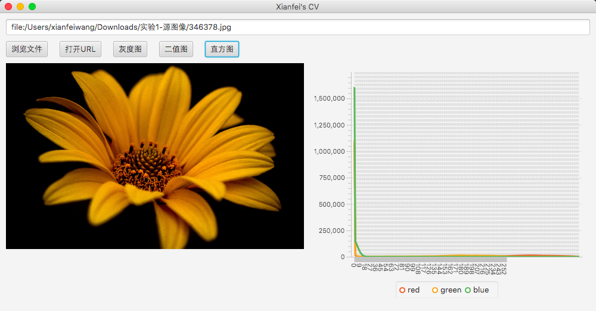
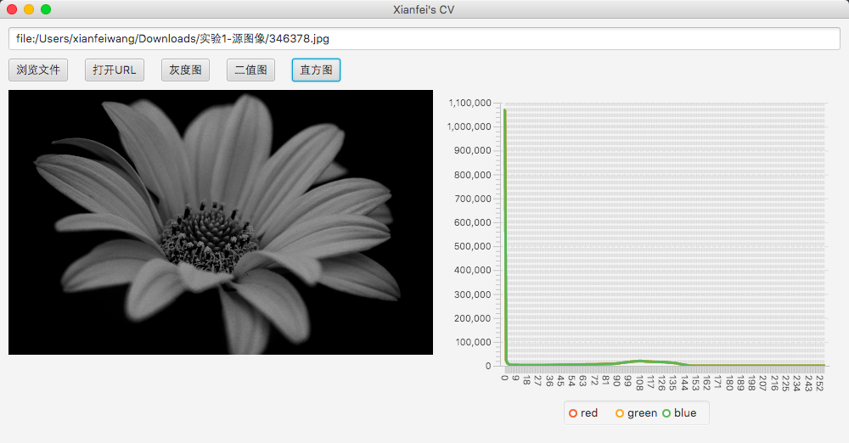
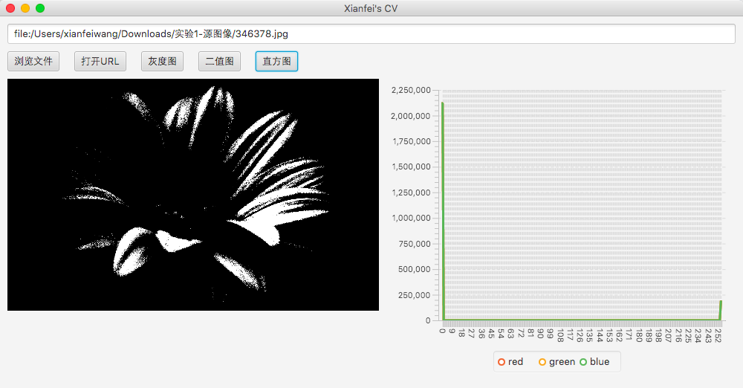
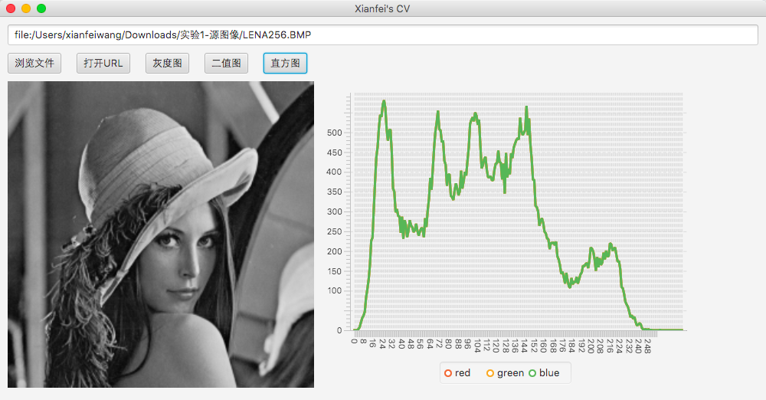
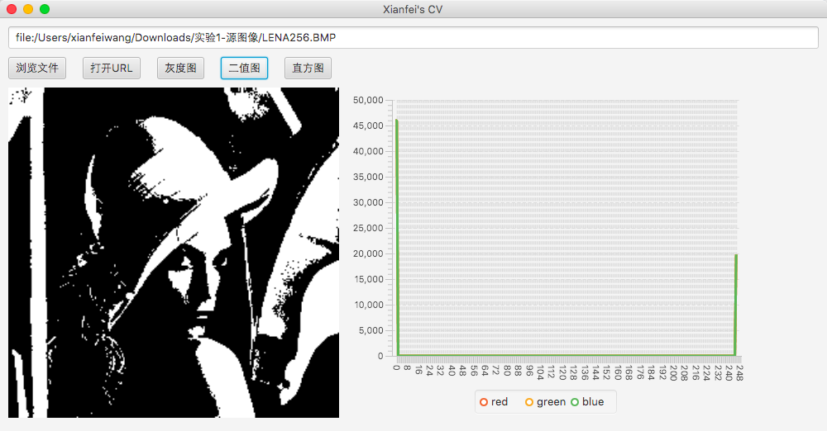
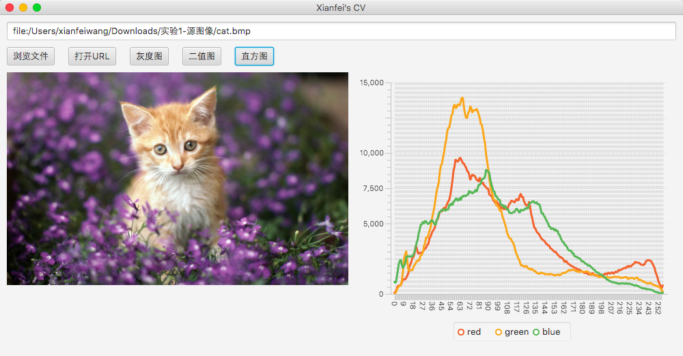
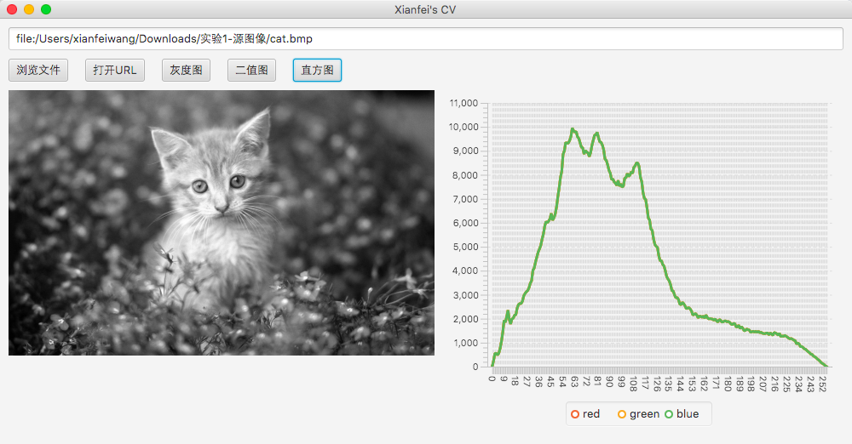
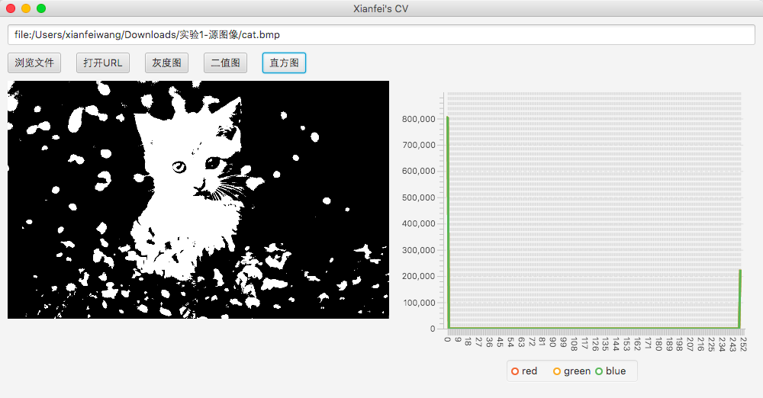
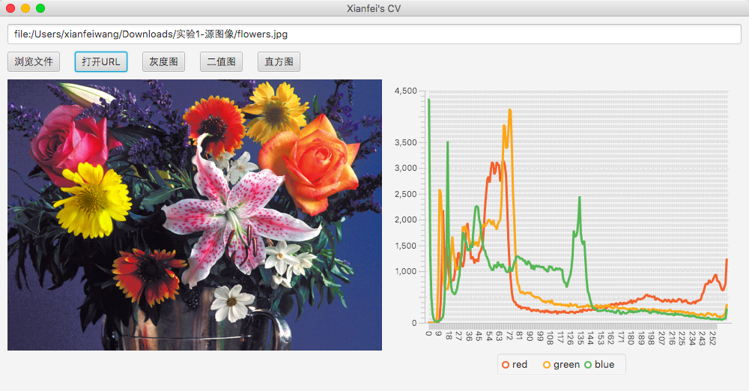
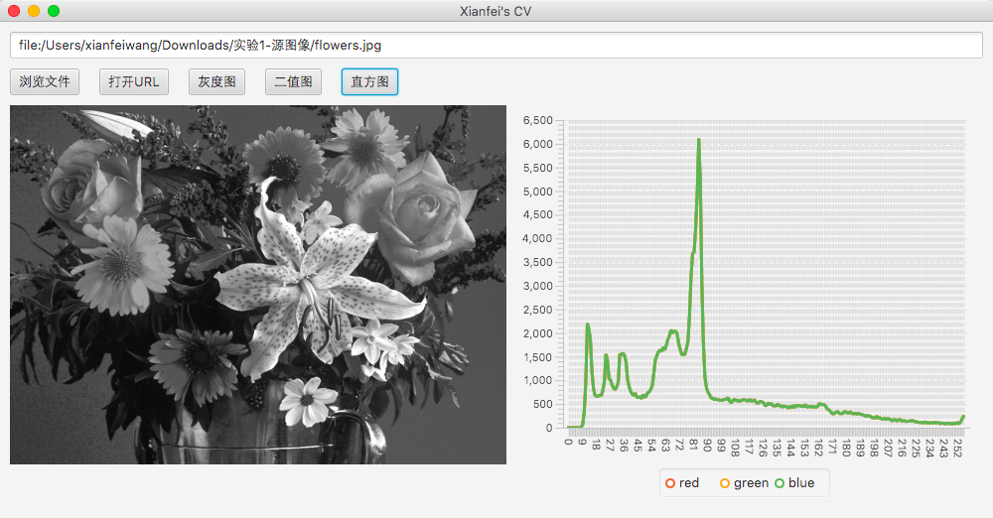
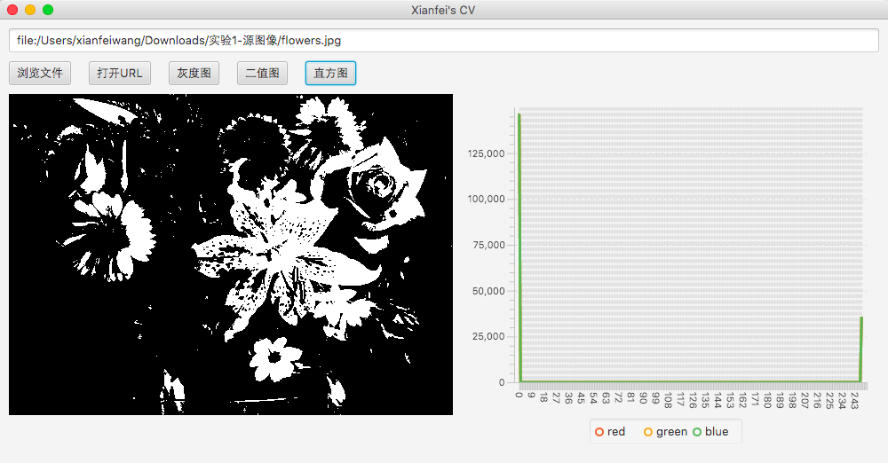
- 附录
心得：自己体验到了对图形进行上述处理的方法，了解到了那些图形处理软件大概的设计思路了。
源代码：
import javafx.application.Application;
import javafx.event.ActionEvent;
import javafx.geometry.Insets;
import javafx.scene.Scene;
import javafx.scene.chart.CategoryAxis;
import javafx.scene.chart.LineChart;
import javafx.scene.chart.NumberAxis;
import javafx.scene.chart.XYChart;
import javafx.scene.control.Button;
import javafx.scene.control.TextField;
import javafx.scene.image.*;
import javafx.scene.layout.HBox;
import javafx.scene.layout.StackPane;
import javafx.scene.layout.VBox;
import javafx.scene.paint.Color;
import javafx.stage.FileChooser;
import javafx.stage.Stage;

public class Main extends Application {

String defaultImage = "";
Image image;

@Override
public void start(Stage primaryStage) {

TextField textSrc = new TextField();
textSrc.setText(defaultImage);
Button btnDo = new Button("直方图");
Button btnFile = new Button("浏览文件");
Button btnUrl = new Button("打开URL");
Button btnWB = new Button("灰度图");
Button btn2z = new Button("二值图");
ImageView imageView = new ImageView();
imageView.setFitHeight(400);
imageView.setFitWidth(500);
imageView.setPreserveRatio(true);
final CategoryAxis xAxis = new CategoryAxis();
final NumberAxis yAxis = new NumberAxis();
final LineChart<String, Number> chartHistogram
= new LineChart<>(xAxis, yAxis);
chartHistogram.setCreateSymbols(false);

// 从url打开图像
btnUrl.setOnAction(e -> {
String imageSrc = textSrc.getText();
image = new Image(imageSrc);
imageView.setImage(image);
});

// 通过文件浏览打开图像
btnFile.setOnAction(e -> {
FileChooser fileChooser = new FileChooser();
fileChooser.setTitle("Open Resource File");
textSrc.setText(fileChooser.showOpenDialog(primaryStage).toURI().toString());
String imageSrc = textSrc.getText();
image = new Image(imageSrc);
imageView.setImage(image);
});

// 转换为灰度图
btnWB.setOnAction(e -> {
WritableImage outputImage = new WritableImage((int) image.getWidth(), (int) image.getHeight());
PixelReader pixelReader = image.getPixelReader();
PixelWriter pixelWriter = outputImage.getPixelWriter();
for (int i = 0; i < (int) image.getWidth(); i++) {
for (int j = 0; j < (int) image.getHeight(); j++) {
double num = ((pixelReader.getColor(i, j).getBlue() + pixelReader.getColor(i, j).getGreen()
+ pixelReader.getColor(i, j).getRed()) / 3);
pixelWriter.setColor(i, j, new Color(num, num, num, 1));
}
}
image = outputImage;
imageView.setImage(image);
});

// 转换为二值图
btn2z.setOnAction(e -> {
WritableImage outputImage = new WritableImage((int) image.getWidth(), (int) image.getHeight());
PixelReader pixelReader = image.getPixelReader();
PixelWriter pixelWriter = outputImage.getPixelWriter();
for (int i = 0; i < (int) image.getWidth(); i++) {
for (int j = 0; j < (int) image.getHeight(); j++) {
double num = ((pixelReader.getColor(i, j).getBlue() + pixelReader.getColor(i, j).getGreen()
+ pixelReader.getColor(i, j).getRed()) / 3);
num = num > 0.5 ? 1 : 0;
pixelWriter.setColor(i, j, new Color(num, num, num, 1));
}
}
image = outputImage;
imageView.setImage(image);
});

// 绘制直方图
btnDo.setOnAction(e -> {
chartHistogram.getData().clear();
ImageHistogram imageHistogram = new ImageHistogram(image);
if (imageHistogram.isSuccess()) {
chartHistogram.getData().addAll(
imageHistogram.getSeriesRed(),
imageHistogram.getSeriesGreen(),
imageHistogram.getSeriesBlue());
}
});

HBox hBox = new HBox();
hBox.getChildren().addAll(imageView, chartHistogram);
HBox butBox = new HBox(20);
butBox.getChildren().addAll(btnFile, btnUrl, btnWB, btn2z, btnDo);

VBox vBox = new VBox(10);
vBox.setPadding(new Insets(10, 10, 10, 10));
vBox.getChildren().addAll(textSrc, butBox, hBox);

StackPane root = new StackPane();
root.getChildren().add(vBox);

Scene scene = new Scene(root, 1000, 500);

primaryStage.setTitle("Xianfei's CV");
primaryStage.setScene(scene);
primaryStage.show();
}

public static void main(String[] args) {
launch(args);
}

class ImageHistogram {

private Image image;
private long red[] = new long[256];
private long green[] = new long[256];
private long blue[] = new long[256];

XYChart.Series seriesRed;
XYChart.Series seriesGreen;
XYChart.Series seriesBlue;

private boolean success;

ImageHistogram(Image src) {
image = src;
success = false;

//init
for (int i = 0; i < 256; i++) {
red[i] = green[i] = blue[i] = 0;
}

PixelReader pixelReader = image.getPixelReader();
if (pixelReader == null) {
return;
}

//count pixels
for (int y = 0; y < image.getHeight(); y++) {
for (int x = 0; x < image.getWidth(); x++) {
int argb = pixelReader.getArgb(x, y);
int r = (0xff & (argb >> 16));
int g = (0xff & (argb >> 8));
int b = (0xff & argb);

red[r]++;
green[g]++;
blue[b]++;

}
}

seriesRed = new XYChart.Series();
seriesGreen = new XYChart.Series();
seriesBlue = new XYChart.Series();
seriesRed.setName("red");
seriesGreen.setName("green");
seriesBlue.setName("blue");

for (int i = 0; i < 256; i++) {
seriesRed.getData().add(new XYChart.Data(String.valueOf(i), red[i]));
seriesGreen.getData().add(new XYChart.Data(String.valueOf(i), green[i]));
seriesBlue.getData().add(new XYChart.Data(String.valueOf(i), blue[i]));
}

success = true;
}

public boolean isSuccess() {
return success;
}

public XYChart.Series getSeriesRed() {
return seriesRed;
}

public XYChart.Series getSeriesGreen() {
return seriesGreen;
}

public XYChart.Series getSeriesBlue() {
return seriesBlue;
}
}

}

